Project Design Phase-II
Solution Requirements (Functional & Non-functional)

Date | 01 October 2026
Team ID | PRIYADHARSHINI S
Project Name | Auto Ticket Classification Using Flow Designer
Maximum Marks | 4 Marks

Technical Architecture:
The Deliverable shall include the architectural diagram as below and the information as per the table1 & table 2
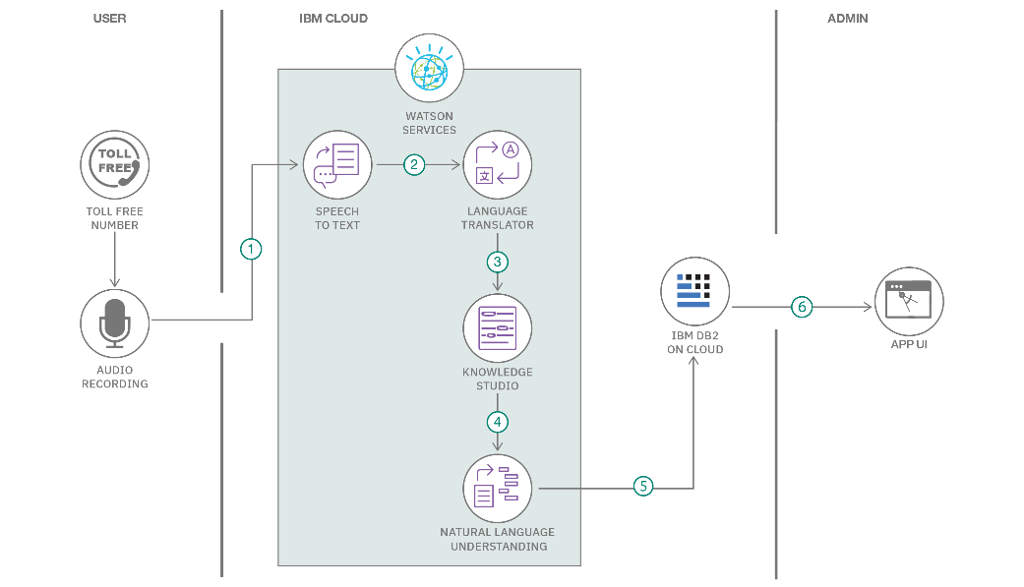
Functional Requirements

FR No. | Functional Requirement (Epic) | Sub Requirement (Story / Sub-Task)
FR -1 | User Registration  DOCX | Registration through Gmail  Registration through LinkedIN  DOCX
FR-2 | User Confirmation  DOCX | Confirmation via OTP  DOCX
FR-3 | Automatic Ticket Categorization | Short Description Keyword Analysis  Automatic Assignment of Category  Automatic Assignment of Subcategory  Dependency Logic Configuration Field
FR -4 | Dynamic Choice Mappings & Email Notification | Automated Confirmation Email to Caller  Update Set Tracking Export

Non-functional Requirements
Following are the non-functional requirements of the proposed solution.

NFR NO. | Non-Functional Requirement | Description
NFR-1 | Usability  DOCX | Simple, no-code UI for students/teachers to submit requests by entering only Caller Name and Short Description without needing to know category choices.
NFR-2 | Security  DOCX | Access control managed via standard ServiceNow Role-Based Access Controls (RBAC), ensuring only authorized IT staff and system flows update ticket categories.
NFR-3 | Reliability  DOCX | Guaranteed accuracy in ticket tagging based on predefined keyword triggers, preventing manual tagging errors and lost tickets.
NFR-4 | Availability  DOCX | High system uptime hosted on ServiceNow cloud infrastructure, providing 24/7 availability for students and teachers to submit IT requests.
NFR-5 | Performance  DOCX | Flow execution triggers immediately on record insertion, updating fields and firing automated emails in under 2 seconds.

References:
- ServiceNow Flow Designer Documentation: https://docs.servicenow.com
- C4 Model for Software Architecture: https://c4model.com/
- IBM Cloud Architecture Center: https://www.ibm.com/cloud/architecture

